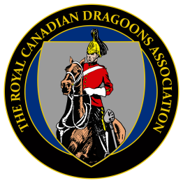

RV22 - Registration Form
17-19 June 2022, Pembroke Ontario

NAME_________________________________________________________________________________
First Nickname Last

Spouse__________________________________________________________________
First Nickname Last

Address_________________________________________________________________
Street City Province

________________________________________________________________________
Postal code Phone Number Email

Number attending____ all activities____ Meet & Greet only ____ Dinner only ____ Golf____

Preferred meal: Chicken ____ Beef____ Special Need ____________
Costs
Meet & Greet only: $15.00 per person
Meet & Greet + Dinner/Dance: $100.00 per person
Golf (TBC based on confirmed Interest): User pay
Specific Agenda: Details to follow

Notes
Room reservations can be made with the Clarion Hotel Pembroke (613-735-6868) using the booking reference RV22 to take advantage of the group rate. Reservations must be made before 10 May 2022.
Announcements and updates will be published in the Dragoon, Chapter newsletters and on www.dragoons.ca.
Special dietary requirements must be specified early by notifying Marc Tremblay at 613-687-8399 or thesens@hotmail.ca

Mail to: Bruce Prendergast, 286 Mink Lake Rd., Eganville ON K0J 1T0

My post-dated cheque (30 April 22) for $_______ is enclosed or I will make an e-transfer later ____

Make cheques payable to; RCD Association Ottawa Valley Chapter.

Please sign the line below if you authorise the RCD Association, Ottawa Valley Chapter to post my name as attending RV22

Member Signature: __________________________Spouse Signature: ___________________

