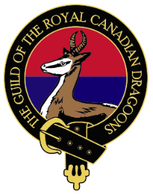
Guild of the Royal Canadian Dragoons

RETIREMENT/RELEASE NOTIFICATION FORM

This form allows members to formally notify the Regimental Family of their impending retirement/release from active service. By filling out this form, you will be initiating a support process managed by the Guild and completely coordinated with you.

SUBMITTING PERSON (if different from the releasing Member)
Name: | Email: |  | Phone:
RETIRING / RELEASING MEMBER INFORMATION
FIRST NAME: |  | LAST NAME:
RANK: |  | SN:
TRADE/MOC: |  | ENROLMENT DATE:
TOURS at The REGT (IUCs 1754 and 6668):
EMAIL (personal preferred): |  | PHONE (personal preferred):
RETIREMENT / RELEASE INFORMATION
CURRENT UNIT:
UNIT LOCATION:
RETIREMENT/RELEASE DATE:
DEPART WITH DIGNITY DATE (if known):
DWD COORDINATOR CONACT INFO (if known):
INTENDED RETIREMENT LOCATION (city & province):
OTHER INFORMATION:

By putting an ‘X’ in this box, you acknowledge and give authority to the Guild to gather information by contacting you, the member and the DWD coordinator as well as accessing your CAF MPRR.

CONSENT: By putting an ‘X’ in this box, you agree to allow the Guild will share your retirement information with the Regimental Family and coordinate family-level support transition with you, separate from the official CAF program.

Signature/e-signature: Date:

