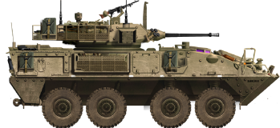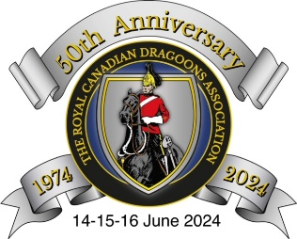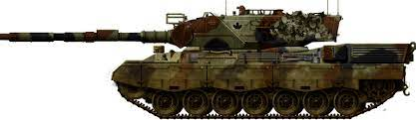

50th Anniversary RCD Assn RV24
14-16 June 2024, Kingston Ontario
Registration Form

Name: _________________________________________________________________________________
First Nickname (if applicable) Last Spouse

Address: __________________________________________________________________
Street City Province Postal Code Phone #

Number Attending: ___ All activities ___
Meet & Greet (14 June) only ___ Dinner (15 June) only ___ Golf (14 June) ___

Preferred Meal: 1. Chicken Supreme Herb & Lemon Crust ___ 2. Angus Top Sirloin Steak ___ 3. Special Need / Vegetarian Gnocchi ___

Specific dietary requirements, if applicable: ____________________________________

Costs:

Meet & Greet only: $20.00 per person
Meet & Greet + Dinner & Music: $100.00 per person
Kingston Golf, Penitentiary Tour, Trolley Tour (TBC based on confirmed interest): User pay

Specific Agenda: Details to follow

Hotel Reservations:

Can be made directly with the Quality Inn & Conf Centre, 33 Benson St, Kingston, ON K7K 5W2, (613) 546-3661 (extn 0) – use the Booking Ref ‘Royal Canadian Dragoons Assn’ to take advantage of the group rate. Reservations must be made before 15 May 2024

Announcements:

Updates will be published in the Dragoon, Chapter Newsletters, Dragoon Magazine and/or at: www.dragoons.ca.

Registration Options (please submit before 30 April 2024):

- Mail your completed form to: Tom Newton, 477 Evangeline Ave, Kingston ON K7M 8V7, OR

2. E-Mail your completed form to: tankertom32@gmail.com

Payment Options:

- My cheque for $ ______ (post-dated before 30 April 2024) is enclosed
(please make your cheque payable to: ‘Kingston Chapter, RCD Association’), OR

- I will pay $ ______ via e-transfer to: tankertom32@gmail.com before 30 April 2024

I hereby authorize the RCD Association and Guild to post my name as attending RV24:

Member Signature: ___________________ Spouse Signature: ____________________

