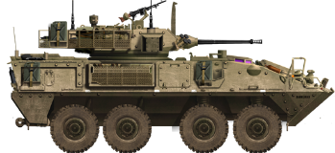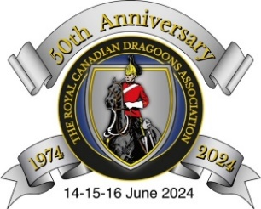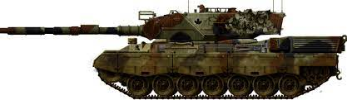

**Schedule of Events**

**RCD Assn 50th Anniversary (RV 24), 14-16 June 2024**

**Friday 14 June 2024**

**1045 - 1500: RCD Assn Golf** (Garrison Golf Course Kingston). Our 8 Tee Times are currently booked from 1051 to 1154, with the final tee time reserved for our organizer – Chris Catry! Registrants may indicate who they'd like to golf with (those individuals must be registered and paid up as well); however, a specific time may not be requested as if we have less than 32 golfers we will simply drop the earlier Tee Times and compress/re-organize the schedule. Costs are: Green Fees $42.94, Power Cart (per person) $27.12 (GGCC members and those with cart packages do not pay). Bookings must be made, with payment up front, **NLT 31 May 24**. Please pay by etransfer to [tankertom32@gmail.com](mailto:tankertom32@gmail.com), or by cheque (payable to the Kingston Chapter, RCD Association) if you prefer. There are no prizes or anything like that, just a fun afternoon of golf with fellow Dragoons!

**1500: Arrival and check-in at Quality Inn & Suites Conference Centre.**

**1500 - 1800: Registration in Hotel Lobby (downstairs).** Bill Brough and Tony Slack will be there to meet you in the lobby of the hotel to welcome you and provide you with your Reunion Welcome Package.

**Dinner** (individual arrangements).

**1700 - 1800: RCD Association Director’s Meeting** in the Fort Henry Conference Room, next to hotel reception (TBC by the Assn President).

**1700 - 2100: RCD Guild-Sponsored Meet and Greet** in Cartier ‘B’ Ballroom (casual dress, cash bar), with hot & cold hors d’oeuvres served from 1800-2000. A Regimental historical display will also be set up in the ballroom.

**1900 - 2100: RCD Kit Shop available** in the ballroom.

**Saturday 15 June 2024**

**0700 - 0900: Breakfast** (individual arrangements).

**0900 - 1100: Spousal Program** (coffee/tea/snacks available in the Cartier ‘A’ Ballroom – sponsored by The Guild).

**0900 - 1130: RCD Association General Meeting** in the Cartier ‘B’ Ballroom (coffee/tea available).

**1130 - 1700: Lunch (individual arrangements) / Free Time / Visit Downtown Kingston and attractions.** Please make your own bookings. There are many attractions – please see attached summary!

**1745 - 1830: Portraits (2 x Soldiers in Scarlets).**

**1800 - 2400: Mixed Dining-In**. The reception desk will open at 1800 and the bar will be available in the ballroom at that time. The dinner service will then commence at 1900. Dress for the evening is business casual. The CO & RSM (and 4 SSMs from the Regiment) will be joining us, along with several Soldiers, including the Soldiers in Scarlets. As per the Registration Form, we will have excellent meal options (and chocolate cake for dessert!), as well as some background music and a piper. Dinner shall be served as the speeches proceed, so that we can keep the evening activities flowing smoothly. Depending on the size of our group we may be able to open up a portion of the ballroom for dancing for those who are interested.

**Sunday 16 June 2024**

Breakfast (individual arrangements), farewell to friends and departure on own time.